 | MEMBERSHIP SUBSCRIPTION FORM

YES, I WILL JOIN DALIT SOLIDARITY NETWORK–UK AND SAY NO TO CASTE

PLEASE DO NOT SEND THIS FORM TO YOUR BANK

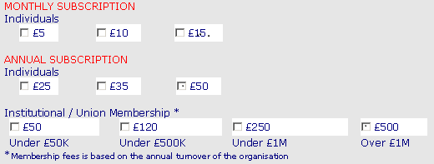

Name ______________________________________________________________________________

Address ____________________________________________________________________________

___________________________________________________________________________________

Postcode ___________________________ Country _________________________________________

Telephone __________________________ E-Mail __________________________________________

INSTRUCTIONS TO YOUR BANK OR BUILDING SOCIETY

Name of account holder(s)
 |  | Reference No. (Office use only)
Bank/Building Society account number  Branch sort code  Name and full postal address of your Bank or Building Society branch |  | Instructions to your Bank or Building Society.  Please pay DSN-UK a Standing Order from the account detailed in this instruction,  starting date __/__/__  DSN-UK Ac. No. 1436709  LLOYDS TSB Plc. (Sort Code: 30-92-89)
  To, The Manager Bank/Building Society
  Address
  Post Code
  Signature(s)
  Date
GIFT AID DECLARATION (Individuals Only)

 | Please tick if you would like DSN-UK to reclaim the tax you have paid on your donations. You must have paid UK income or capital gains tax equal to that claimed (28p in the £1)
Signature |  |  | Date
Please keep me informed about the work that DSN-UK is doing
PLEASE COMPLETE AND RETURN TO

The Director, Dalit Solidarity Network-UK, Canopi, 82 Tanner Street, London, SEI 3GN. Email: info:Dsnuk.org
REGISTERED CHARITY NO. 1107022

